**Task 01: Use Html 5, make this UI. You should use only table tag and form.**

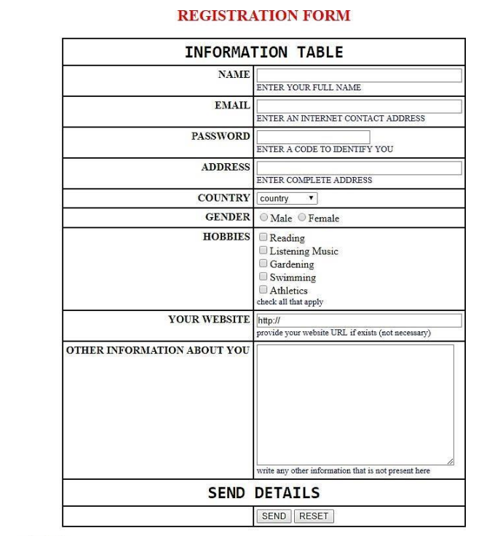

**Task 02: Use table tag in html, make this layout of web page.**

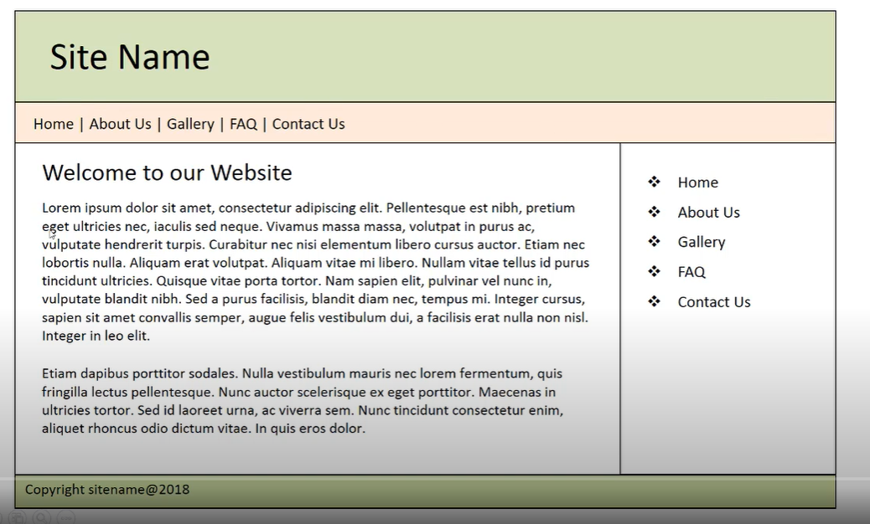

**Task 03: Click on this link** [**https://www.webicosoft.com/**](https://www.webicosoft.com/)**. and create this page using HTML 5 and CSS3.**

**Hints:**

Make sure you use section tag for every UI Component. Do not use library or framework for achieving the goal.

Use the following tags:

1. Section.
2. Header.
3. Nav
4. Footer.